Department of Mechanical Engineering
Galgotias University

AERODYNAMICS OF VEHICLES BAUT3063

TOPIC- BOUNDARY LAYER SEPARATION

Submitted to: Dr. Faisal Shameem Sir

Student Name: Bishnu Bishwakarma
Admission No: 19SCME1050013
Course: B. Tech in Automobile Engineering

Modelling:
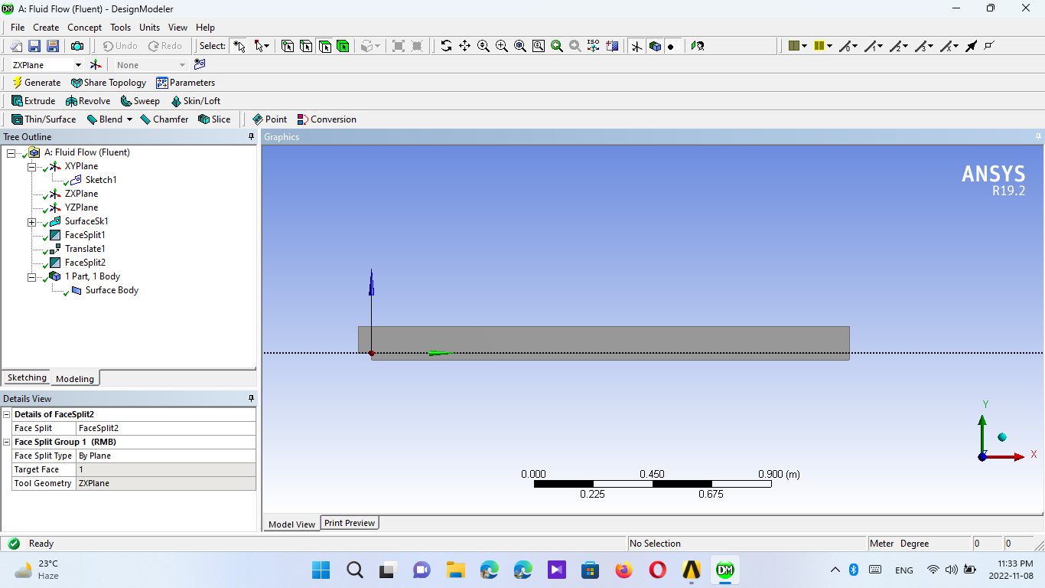

Meshing:
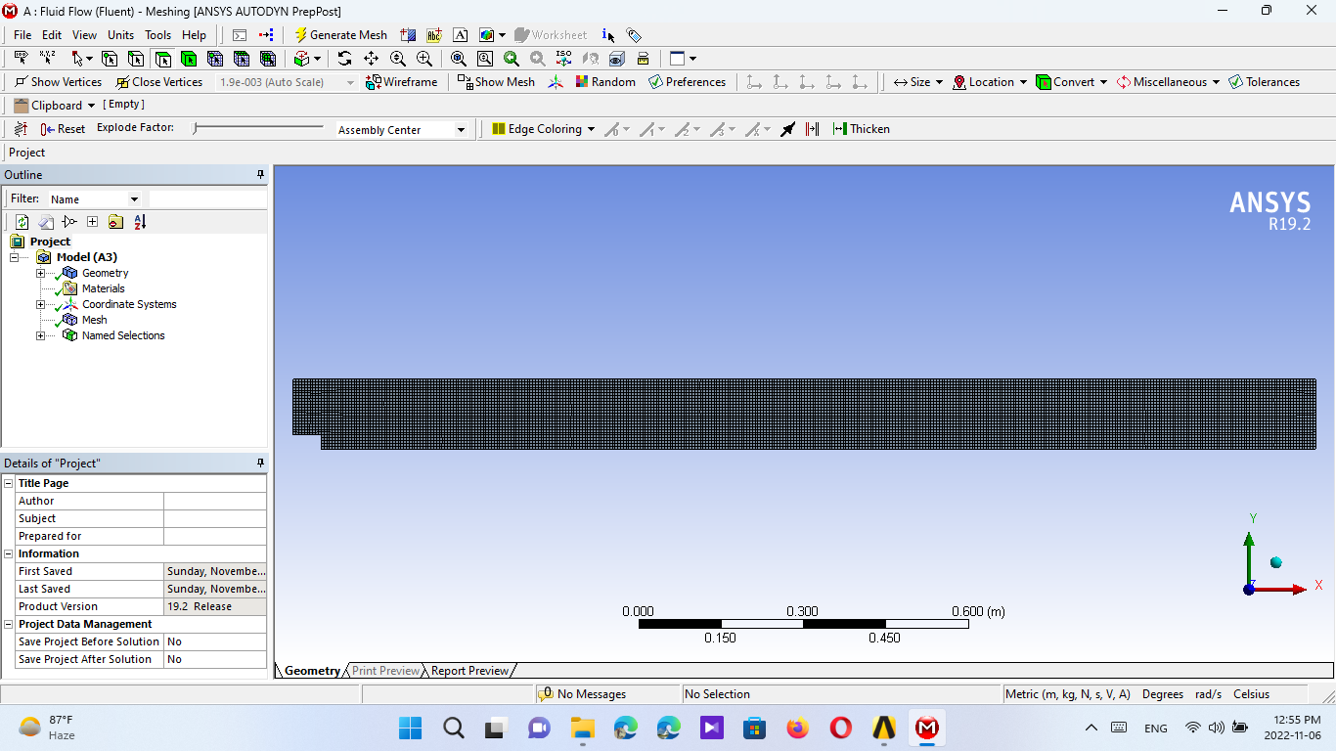

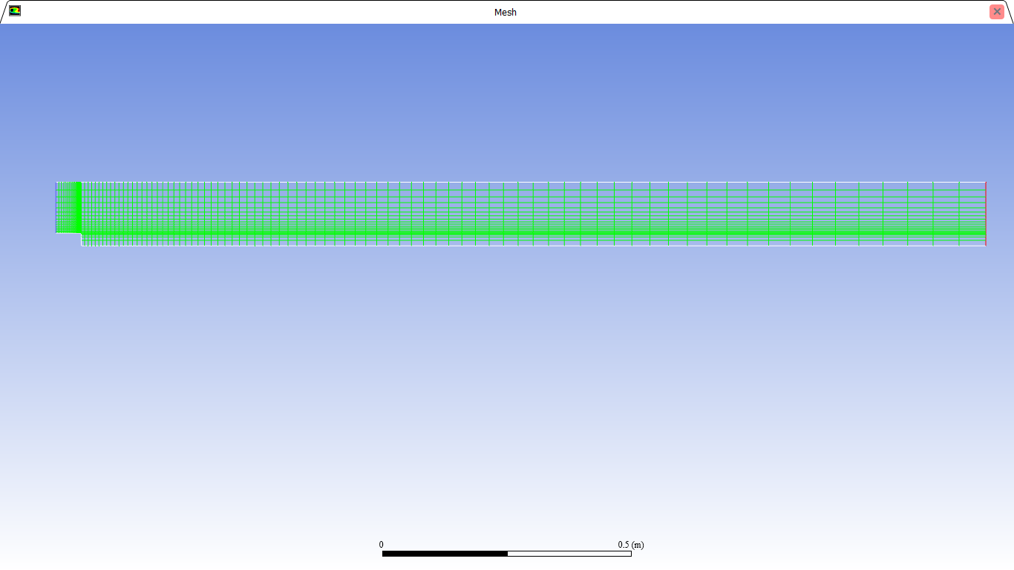

Result:
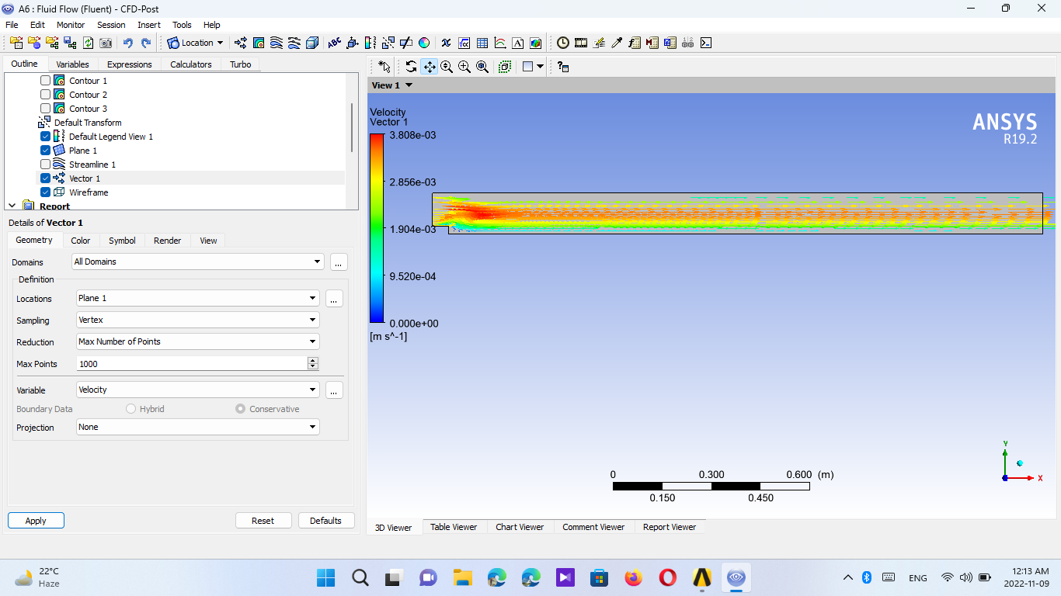
Fig: - Velocity Vector

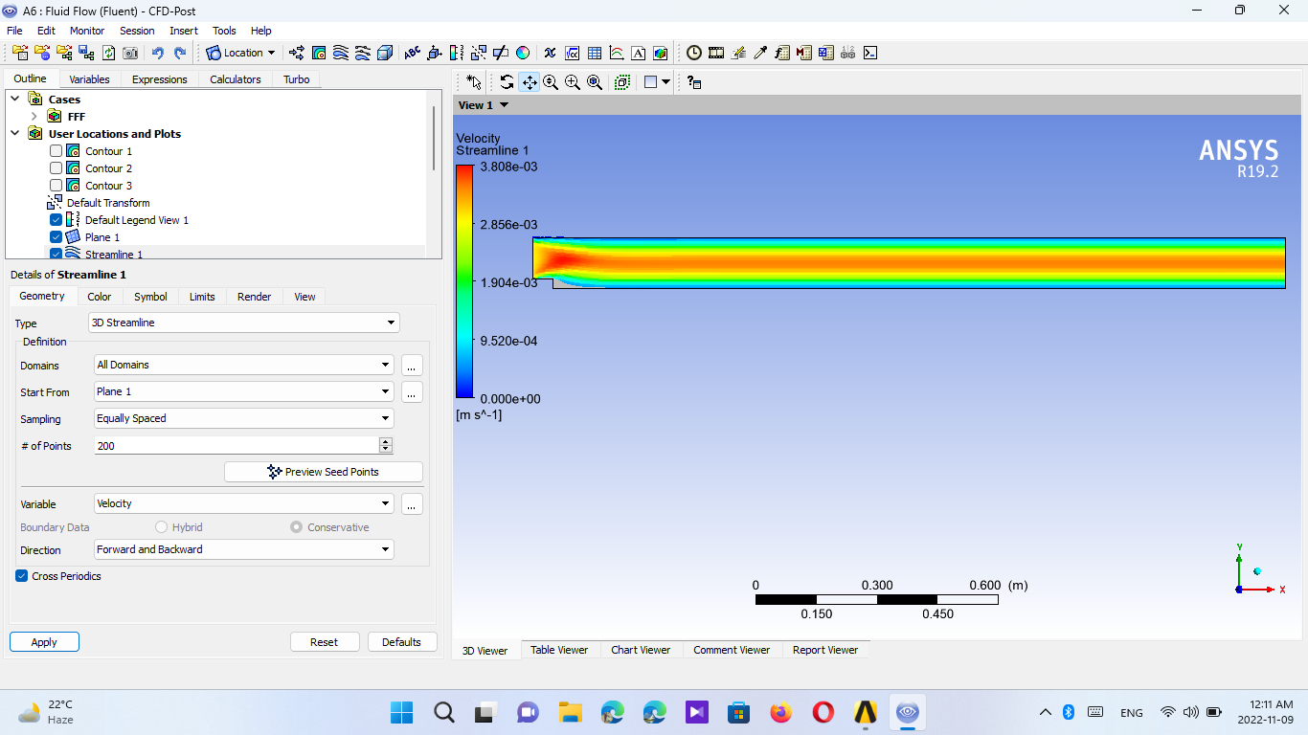
Fig: - Velocity Streamline
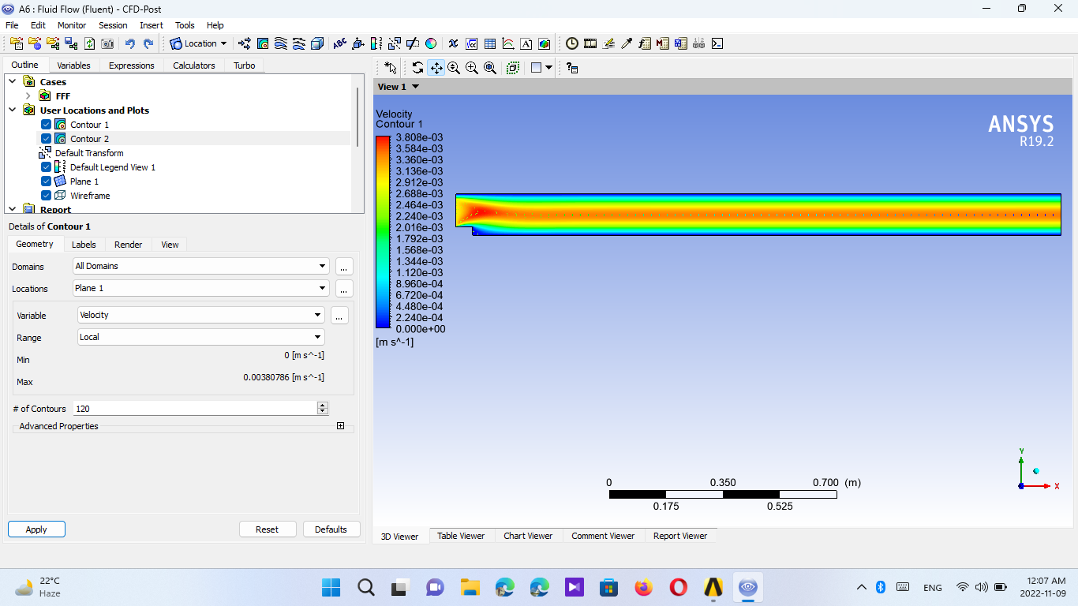
Fig: -Velocity Contour

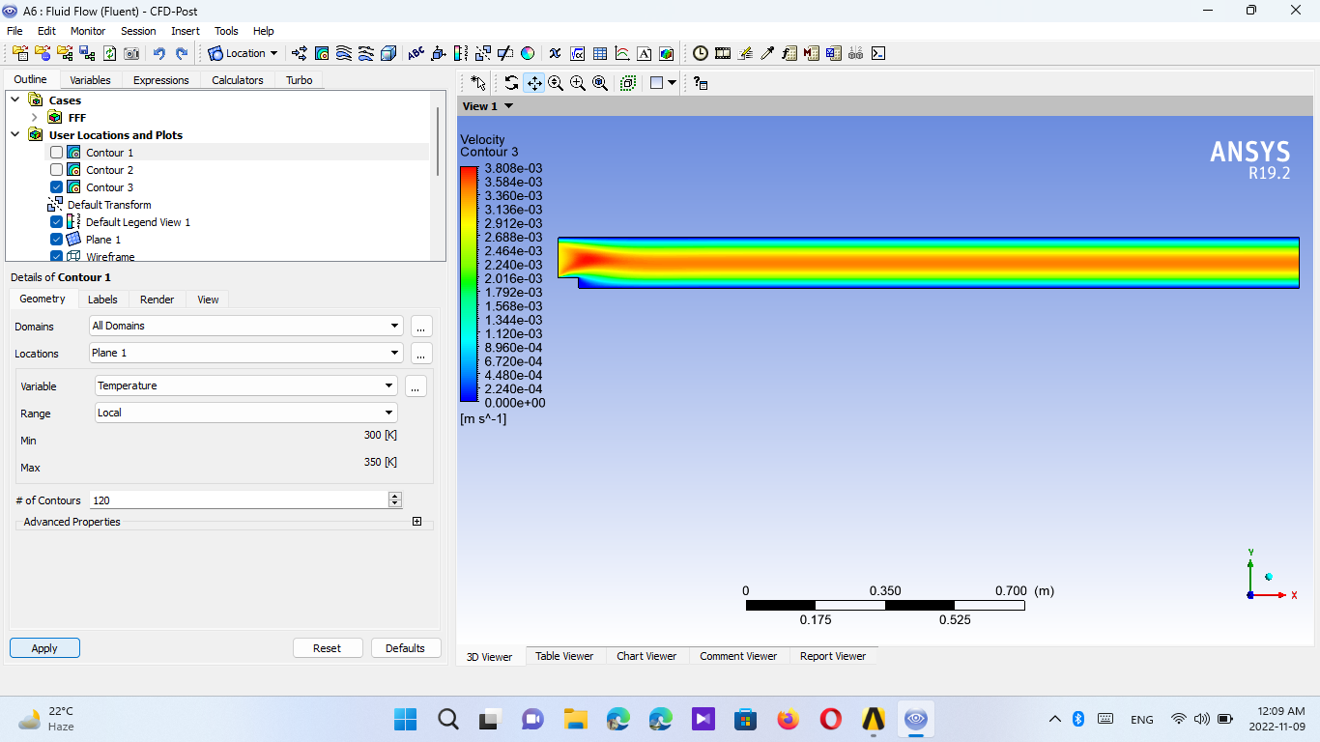
Fig: - Velocity Contour - 3
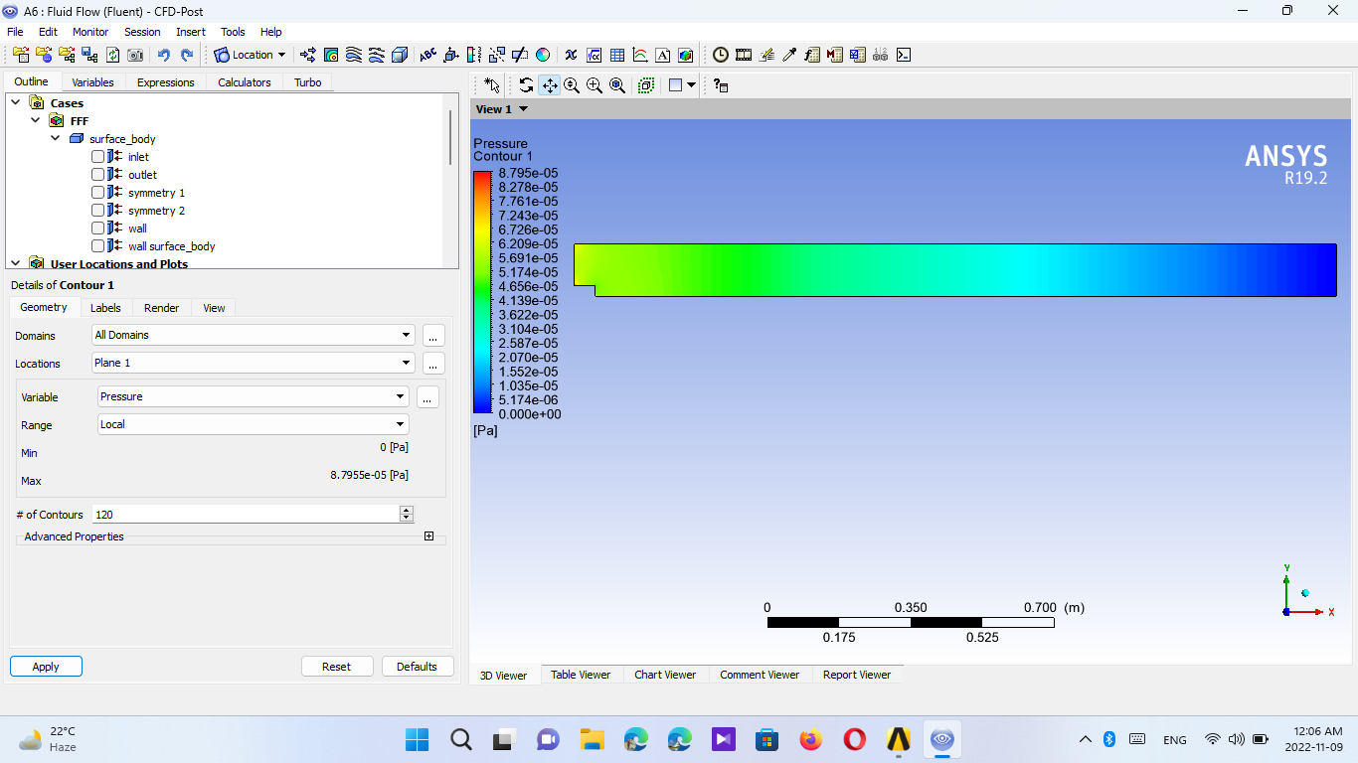
Fig: - Pressure Contour – 1

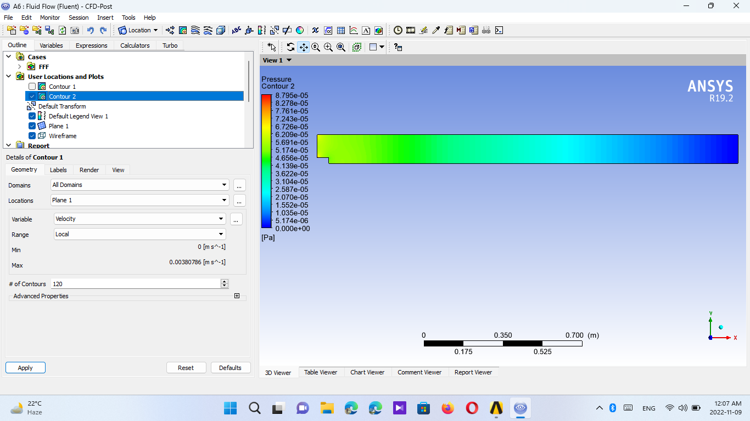
Fig: - Pressure Contour – 2

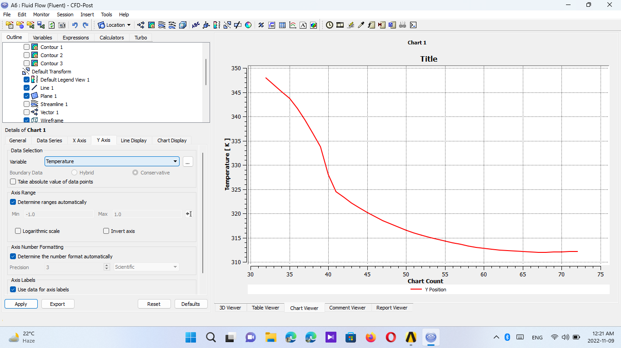
Fig: - Temperature Vs Chart Count

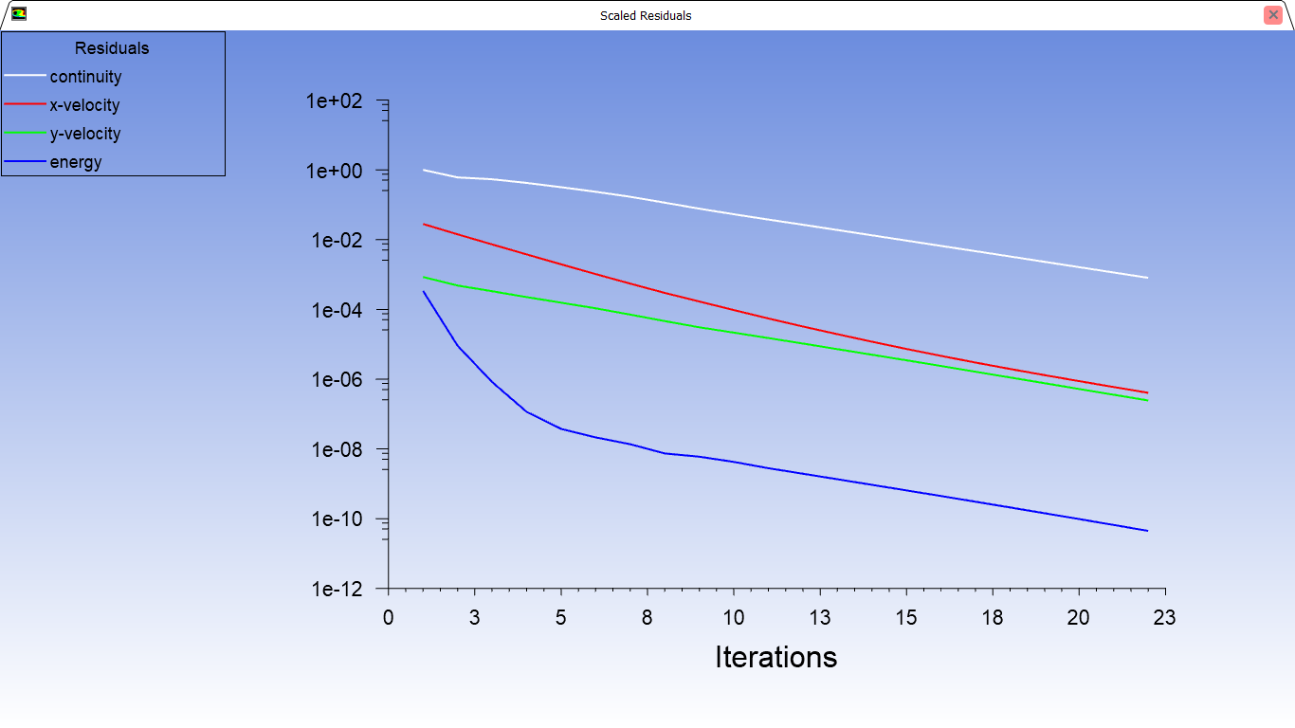
Fig: - Iterations

